To estimate the mean, variance, standard deviation, and coefficient of variation (CV) for the given grouped frequency distribution, we follow these steps:
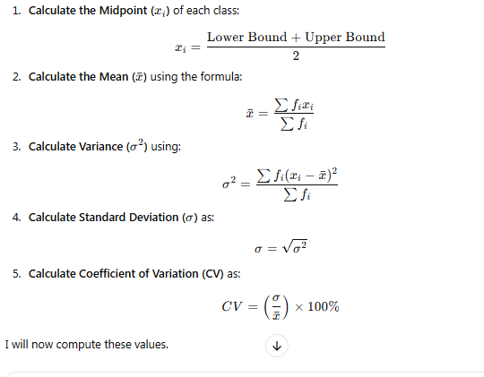
I will now compute these values.
Here are the estimated values for the given grouped frequency distribution:
- Mean (xˉ\bar{x}xˉ) = 2.24
- Variance (σ2\sigma^2σ2) = 0.424
- Standard Deviation (σ\sigmaσ) = 0.651
- Coefficient of Variation (CV) = 29.10%
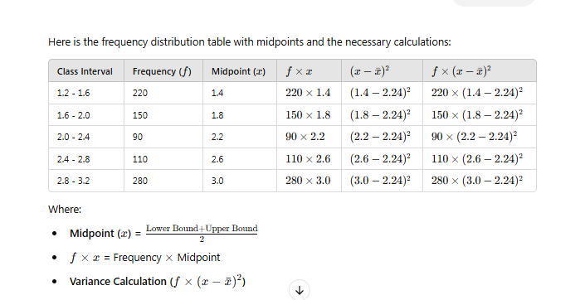

import numpy as np

# Given class intervals and frequencies
classes = [(1.2, 1.6), (1.6, 2.0), (2.0, 2.4), (2.4, 2.8), (2.8, 3.2)]
frequencies = [220, 150, 90, 110, 280]

# Calculate midpoints
midpoints = [(c[0] + c[1]) / 2 for c in classes]

# Calculate Mean
total_freq = sum(frequencies)
mean = sum(f * x for f, x in zip(frequencies, midpoints)) / total_freq

# Calculate Variance
variance = sum(f * (x - mean) ** 2 for f, x in zip(frequencies, midpoints)) / total_freq

# Standard Deviation
std_dev = np.sqrt(variance)

# Coefficient of Variation (CV)
cv = (std_dev / mean) * 100

mean, variance, std_dev, cv

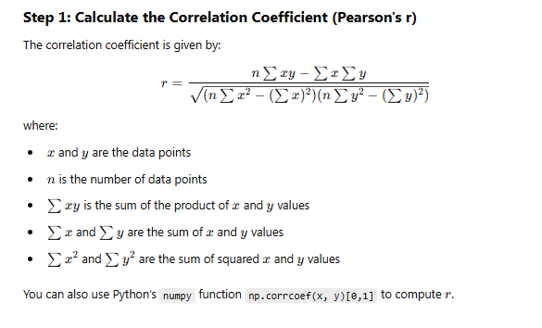

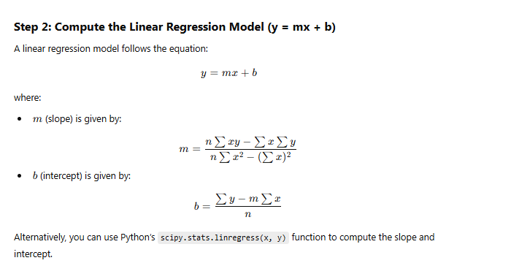
Here is the Python code and results for calculating the correlation coefficient and linear regression model:

Python Code:
import numpy as np
import scipy.stats as stats

def calculate_correlation_and_regression(x, y):
# Compute correlation coefficient
r = np.corrcoef(x, y)[0, 1]

# Compute linear regression (slope and intercept)
slope, intercept, _, _, _ = stats.linregress(x, y)

# Regression equation
regression_eq = f"y = {slope:.2f}x + {intercept:.2f}"

return r, regression_eq

# Given datasets
dataset_1_x = np.array([1, 2, 3, 4, 5, 6, 7, 8])
dataset_1_y = np.array([30, 45, 51, 57, 60, 65, 70, 71])

dataset_2_x = np.array([100, 120, 140, 160, 170])
dataset_2_y = np.array([75, 90, 115, 140, 155])

# Calculate for both datasets
result_1 = calculate_correlation_and_regression(dataset_1_x, dataset_1_y)
result_2 = calculate_correlation_and_regression(dataset_2_x, dataset_2_y)

print(result_1)
print(result_2)

Results:

Dataset i:
- Correlation Coefficient: 0.9629 (Strong positive correlation)
- Linear Regression Model: y = 5.44x + 31.64

Dataset ii:
- Correlation Coefficient: 0.9946 (Very strong positive correlation)
- Linear Regression Model: y = 1.16x - 44.88
# Re-import necessary libraries since execution state was reset
import numpy as np
import scipy.stats as stats

def calculate_correlation_and_regression(x, y):
# Compute correlation coefficient
r = np.corrcoef(x, y)[0, 1]

# Compute linear regression (slope and intercept)
slope, intercept, _, _, _ = stats.linregress(x, y)

# Regression equation
regression_eq = f"y = {slope:.2f}x + {intercept:.2f}"

return r, regression_eq

# Given datasets
dataset_1_x = np.array([1, 2, 3, 4, 5, 6, 7, 8])
dataset_1_y = np.array([30, 45, 51, 57, 60, 65, 70, 71])

dataset_2_x = np.array([100, 120, 140, 160, 170])
dataset_2_y = np.array([75, 90, 115, 140, 155])

# Calculate for both datasets
result_1 = calculate_correlation_and_regression(dataset_1_x, dataset_1_y)
result_2 = calculate_correlation_and_regression(dataset_2_x, dataset_2_y)

result_1, result_2

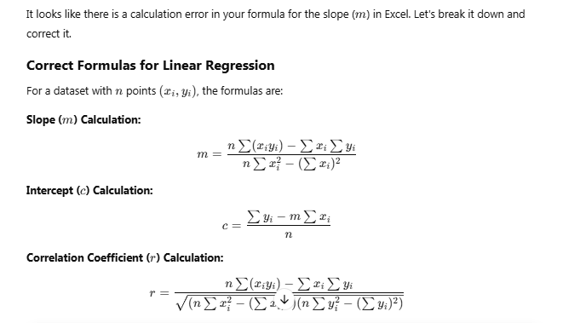
Fixing Your Excel Formulas
Fixing mmm Calculation:
Your formula:

[5*83150 - 680*575] / [5*98500 - (690^2)]

Correction:
Change "680" to "690" (since the sum of xix_ixi​ is 690, not 680)

= (5 * 83150 - 690 * 575) / (5 * 98500 - 690^2)

Fixing ccc Calculation:
Your formula should be:

= (575 - (m * 690)) / 5

Replace "m" with the correct cell reference.

Fixing Correlation Coefficient (rrr) Calculation:
Your formula:

[n*Σxi*yi - Σxi*Σyi] / sqrt[(n*Σxi*xi - (Σxi)^2)*(n*Σyi*yi - (Σyi)^2)]

Correction:

= (5 * 83150 - 690 * 575) / SQRT((5 * 98500 - 690^2) * (5 * 70575 - 575^2))

Final Corrected Excel Formulas:
- Slope (mmm):

=(5 * 83150 - 690 * 575) / (5 * 98500 - 690^2)
- Intercept (ccc):

=(575 - (m * 690)) / 5

(Replace m with the correct cell reference)
- Correlation Coefficient (rrr):

=(5 * 83150 - 690 * 575) / SQRT((5 * 98500 - 690^2) * (5 * 70575 - 575^2))

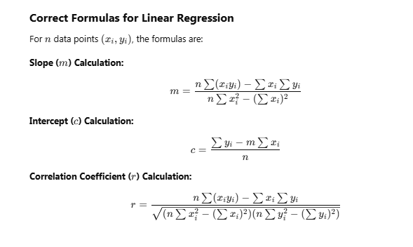

Fixing Your Excel Formulas

1️⃣ Fixing mmm Calculation:
Your current formula:
[n*Σxi*yi - Σxi*Σyi] / [n*Σxi*xi - (Σxi)^2]
Correct Excel Formula:

= (8 * 11193 - 318 * 279) / (8 * 12764 - 318^2)

2️⃣ Fixing ccc Calculation:
Your current formula:
(Σyi - m*Σxi) / n
Correct Excel Formula:
= (279 - (m * 318)) / 8
(Replace m with the correct cell reference.)

3️⃣ Fixing Correlation Coefficient (rrr) Calculation:
Your current formula:
[n*Σxi*yi - Σxi*Σyi] / sqrt[(n*Σxi*xi - (Σxi)^2) * (n*Σyi*yi - (Σyi)^2)]
Correct Excel Formula:
= (8 * 11193 - 318 * 279) / SQRT((8 * 12764 - 318^2) * (8 * 9857 - 279^2))

Final Corrected Excel Formulas:
- Slope (mmm)
= (8 * 11193 - 318 * 279) / (8 * 12764 - 318^2)
- Intercept (ccc)
= (279 - (m * 318)) / 8
- Correlation Coefficient (rrr)
= (8 * 11193 - 318 * 279) / SQRT((8 * 12764 - 318^2) * (8 * 9857 - 279^2))

